Project Design Phase-II Technology Stack (Architecture & Stack)

|  |  |
| --- | --- |
| Date | 15October2022 |
| Team ID | PNT2022TMID11924 |
| Project Name | Project - Personal expense tracker application |
| Maximum Marks | 4 Marks |

# Technical Architecture:

The Deliverable shall include the architectural diagram as below and the information as per the table1 & table 2

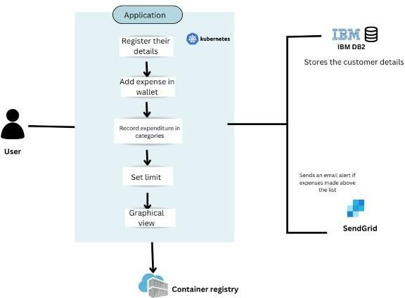

# Table-1 : Components & Technologies:

|  |  |  |  |
| --- | --- | --- | --- |
| **S.No** | **Component** | **Description** | **Technology** |
| 1. | User Interface | How user interacts with application e.g.Web UI, Mobile App, etc. | HTML, CSS, Python flask |
| 2. | Registration | User register in the application to start the process | HTML, CSS, Python flask, IBM cloud,IBM  DB2, IBM Container registry |
| 3. | Login | User login to their account | HTML, CSS, Python flask, IBM cloud,IBM  DB2, IBM Container registry |
| 4. | Wallet page | User can add their expenses in the wallet | HTML, CSS, Python flask, IBM cloud, IBM Container registry |
| 5. | Cloud Database | Database Service on Cloud | IBM DB2, IBM Cloudant etc. |
| 6. | Email alert | User can be notified when their expenses cross thelimit in  the wallet | Kubernetes, IBM container registry,Sendgrid |
| 7. | Graphical view | User can able to see their monthly expenses in agraph  format | IBM cloud object storage, IBM container  registry, HTML, CSS |

**Table-2: Application Characteristics:**

|  |  |  |  |
| --- | --- | --- | --- |
| **S.No** | **Characteristics** | **Description** | **Technology** |
| 1. | Open-Source Frameworks | Docker and kubernetes are the open sourceframeworks | Docker, Kubernetes |
| 2. | Security Implementations | IBM DB2 is used for the security control | IBM DB2 |
| 3. | Scalable Architecture | This architecture connects the three dimensions like processing, storage and connectivity betweenthe user and  the system | Python flask, IBM container registry |
| 4. | Availability | It is always available | Python flask and IBM cloud |
| 5. | Performance | The application can perform well user can experience the fast while using the application | Python flask and IBM cloud |